
St. John’s Episcopal Church
76 Market Street, Salem, NJ 08079
856-935-1798
Established 1722

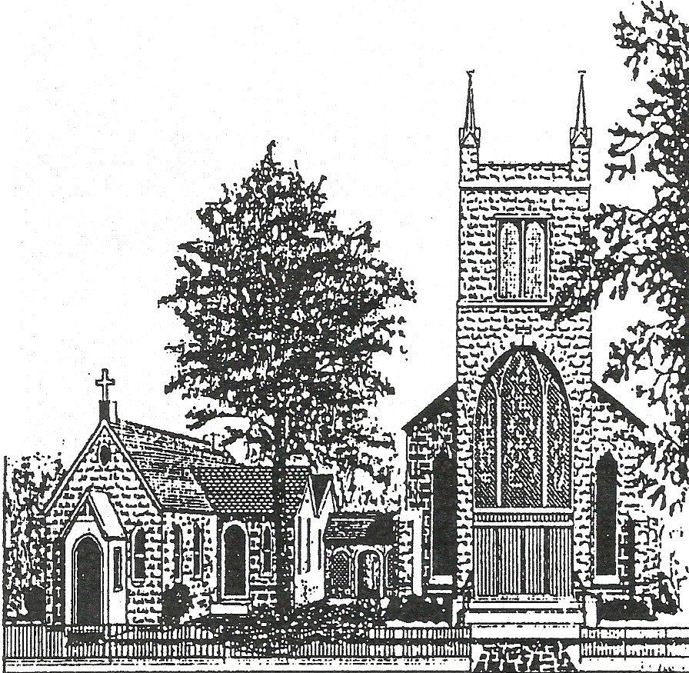
The Third Sunday After Pentecost
June 18, 2023
Holy Eucharist-Rite II
10:30 a.m.

Please make sure all phones and other electronic devices are turned off prior to the service.

Hymns and service music can be found in the following resources:

S - in the front of the Hymnal
H - in the Hymnal
W - in Wonder, Love, & Praise (on the end of each row)
L - in Lift Every Voice (on the end of each row)

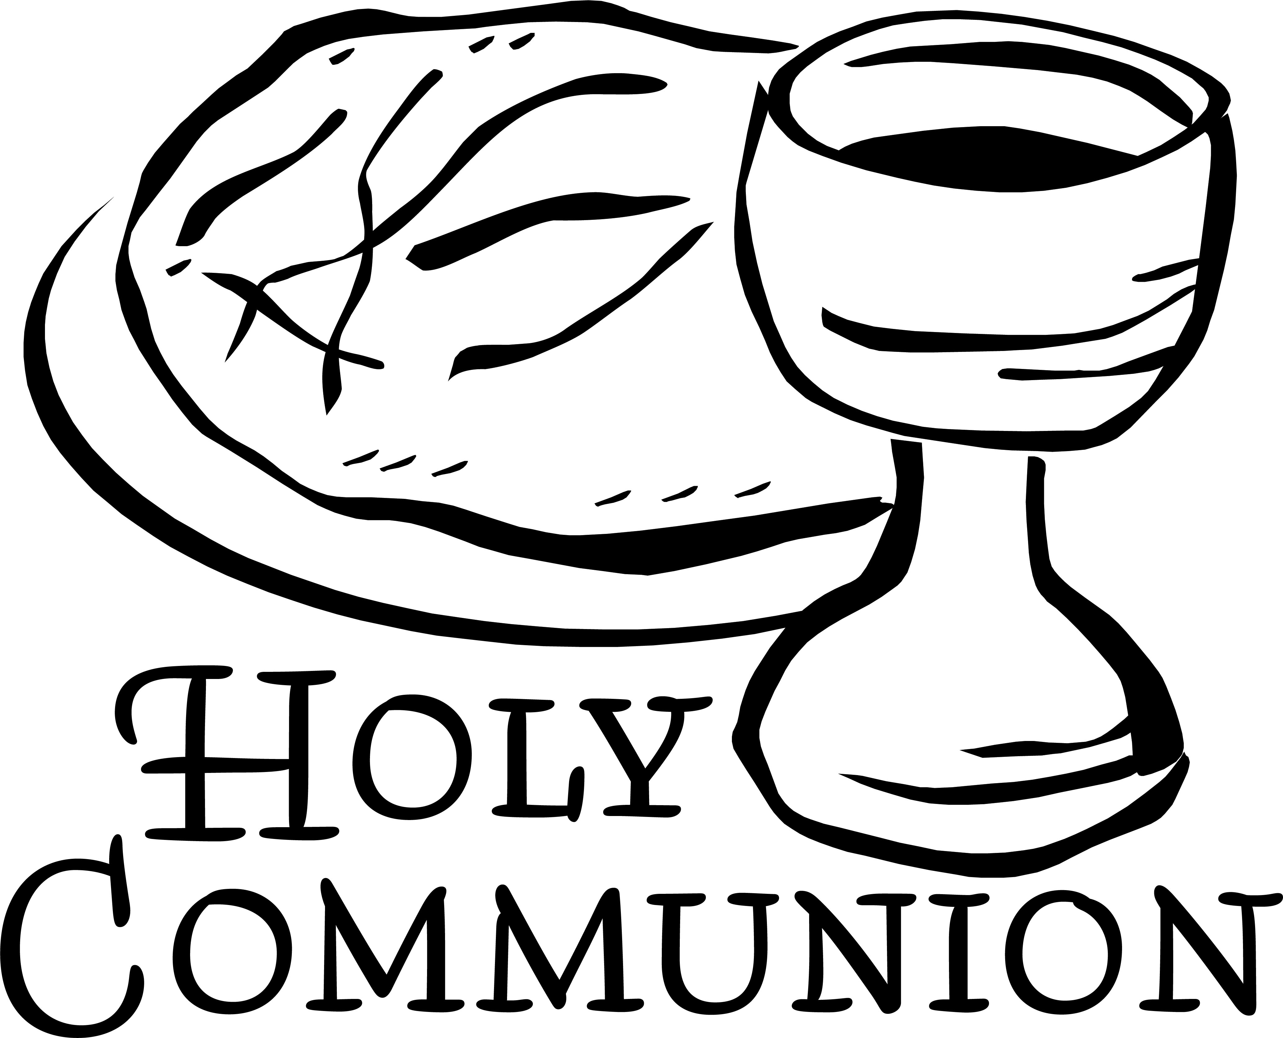
We will be returning to the use of the common cup during communion with both Christ’s Body & Blood. You may choose to sip from the cup or intinct (dip) the host. Following the teaching of our Episcopal tradition, all persons may, but no person must, receive communion in both kinds to receive the full spiritual benefits of communion. You may choose to receive only the host at this time.

THE WORD OF GOD

Organ Prelude Prelude in D Major Frazer M. Gartshore
Processional Hymn Before the Lord’s Eternal Throne H-391 WINCHESTER NEW

Opening Salutation BCP-355
The Collect for Purity BCP-355
Gloria in Excelsis Setting by Robert Powell S-280

The Collect of the Day
Keep, O Lord, your household the Church in your steadfast faith and love, that through your grace we may proclaim your truth with boldness, and minister your justice with compassion; for the sake of our Savior Jesus Christ, who lives and reigns with you and the Holy Spirit, one God, now and for ever. Amen.

The Old Testament Genesis 18:1-15

Lector: A reading from the book of Genesis
The Lord appeared to Abraham by the oaks of Mamre, as he sat at the entrance of his tent in the heat of the day. He looked up and saw three men standing near him. When he saw them, he ran from the tent entrance to meet them, and bowed down to the ground. He said, “My lord, if I find favor with you, do not pass by your servant. Let a little water be brought, and wash your feet, and rest yourselves under the tree. Let me bring a little bread, that you may refresh yourselves, and after that you may pass on—since you have come to your servant.” So they said, “Do as you have said.” And Abraham hastened into the tent to Sarah, and said, “Make ready quickly three measures of choice flour, knead it, and make cakes.” Abraham ran to the herd, and took a calf, tender and good, and gave it to the servant, who hastened to prepare it. Then he took curds and milk and the calf that he had prepared, and set it before them; and he stood by them under the tree while they ate.
They said to him, “Where is your wife Sarah?” And he said, “There, in the tent.” Then one said, “I will surely return to you in due season, and your wife Sarah shall have a son.” And Sarah was listening at the tent entrance behind him. Now Abraham and Sarah were old, advanced in age; it had ceased to be with Sarah after the manner of women. So Sarah laughed to herself, saying, “After I have grown old, and my husband is old, shall I have pleasure?” The Lord said to Abraham, “Why did Sarah laugh, and say, ‘Shall I indeed bear a child, now that I am old?’ Is anything too wonderful for the Lord? At the set time I will return to you, in due season, and Sarah shall have a son.” But Sarah denied, saying, “I did not laugh”; for she was afraid. He said, “Oh yes, you did laugh.”
Lector: The Word of the Lord People: Thanks be to God

Psalm 116:1, 10-17 Dilexi, quoniam BCP-759 Anglican Chant setting sung by choir William Crotch

1 I love the Lord, because he has heard the voice of my supplication, *
because he has inclined his ear to me whenever I called upon him.
10 How shall I repay the Lord *
for all the good things he has done for me?
11 I will lift up the cup of salvation *
and call upon the Name of the Lord.
12 I will fulfill my vows to the Lord *
in the presence of all his people.
13 Precious in the sight of the Lord *
is the death of his servants.
14 O Lord, I am your servant; *
I am your servant and the child of your handmaid;
you have freed me from my bonds.
15 I will offer you the sacrifice of thanksgiving *
and call upon the Name of the Lord.
16 I will fulfill my vows to the Lord *
in the presence of all his people,
17 In the courts of the Lord'S house, *
in the midst of you, O Jerusalem.
Hallelujah!

The Epistle Romans 5:1-8

Lector: A reading from the letter of Paul to the Romans
Since we are justified by faith, we have peace with God through our Lord Jesus Christ, through whom we have obtained access to this grace in which we stand; and we boast in our hope of sharing the glory of God. And not only that, but we also boast in our sufferings, knowing that suffering produces endurance, and endurance produces character, and character produces hope, and hope does not disappoint us, because God's love has been poured into our hearts through the Holy Spirit that has been given to us. For while we were still weak, at the right time Christ died for the ungodly. Indeed, rarely will anyone die for a righteous person-- though perhaps for a good person someone might actually dare to die. But God proves his love for us in that while we still were sinners Christ died for us.
Lector: The Word of the Lord People: Thanks be to God

Gradual Hymn O Love of God, How Strong and True H-455 DUNEDIN

The Gospel Please stand Matthew 9:35-10:8

Priest: The gospel of our Lord Jesus Christ according to Matthew People: Glory to You Lord Christ
Jesus went about all the cities and villages, teaching in their synagogues, and proclaiming the good news of the kingdom, and curing every disease and every sickness. When he saw the crowds, he had compassion for them, because they were harassed and helpless, like sheep without a shepherd. Then he said to his disciples, “The harvest is plentiful, but the laborers are few; therefore ask the Lord of the harvest to send out laborers into his harvest.”
Then Jesus summoned his twelve disciples and gave them authority over unclean spirits, to cast them out, and to cure every disease and every sickness. These are the names of the twelve apostles: first, Simon, also known as Peter, and his brother Andrew; James son of Zebedee, and his brother John; Philip and Bartholomew; Thomas and Matthew the tax collector; James son of Alphaeus, and Thaddaeus; Simon the Cananaean, and Judas Iscariot, the one who betrayed him.
These twelve Jesus sent out with the following instructions: “Go nowhere among the Gentiles, and enter no town of the Samaritans, but go rather to the lost sheep of the house of Israel. As you go, proclaim the good news, ‘The kingdom of heaven has come near.’ Cure the sick, raise the dead, cleanse the lepers, cast out demons. You received without payment; give without payment.

Priest: The Gospel of the Lord People: Praise to You Lord Christ

Sermon The Rev. Charles W. Messer

The Nicene Creed BCP-358
Prayers of the People Form VI BCP-392
Honoring Our Graduates
The Peace BCP-360

THE HOLY COMMUNION

Offertory Anthem How Lovely Are the Messengers (St. Paul) Felix Mendelssohn

How lovely are the messengers that preach us the gospel of peace!
To all the nations is gone forth the sound of their words,
throughout all the lands their glad tidings.
[Romans 10:15]

Presentation: H-380 (v. 3) OLD 100th
Praise God from whom all blessings flow;
Praise Him, all creatures here below;
Praise Him above, ye heavenly host;
Praise Father, Son, and Holy Ghost.

Eucharistic Prayer A BCP-361
Sanctus (sung) Setting by Robert Powell S-129
Acclamation Setting by William Clisham
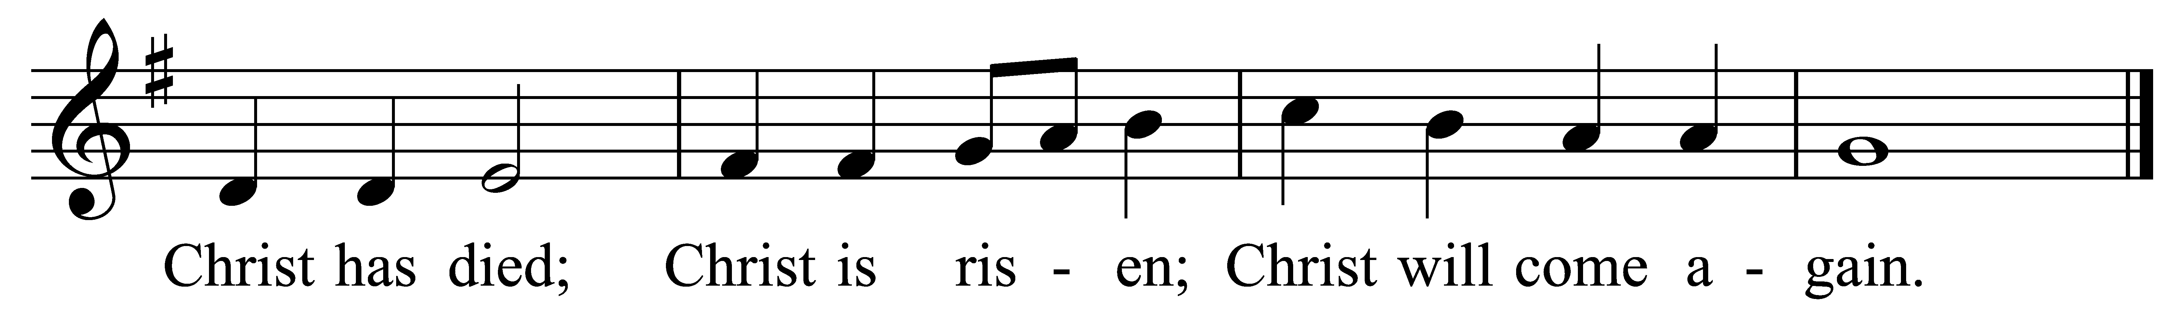
Amen Setting by McNeil Robinson II S-146
The Lord’s Prayer BCP-364
Fraction Anthems
Christ Our Passover David Hurd S-154
Agnus Dei David Hurd S-161
The Breaking of the Bread BCP-364
All are Welcome to Receive Communion.

Communion Hymn Come Down, O Love Divine H-516 DOWN AMPNEY

Prayer for Receiving Spiritual Communion
My Jesus, I believe that you are truly present in the Blessed Sacrament of the Altar. I love you above all things, and long for you in my soul. Since I cannot now receive you sacramentally, come at least spiritually into my heart. As though you have already come, I embrace you and unite myself entirely to you; never permit me to be separated from you. Amen.

Post Communion Prayer
Eternal God, heavenly Father, you have graciously accepted us as living members of your Son our Savior Jesus Christ, and you have fed us with spiritual food in the Sacrament of his Body and Blood. Send us now into the world in peace, and grant us strength and courage to love and serve you with gladness and singleness of heart; through Christ our Lord. Amen.

The Blessing BCP-366
Retiring Procession Come, Labor On H-541 ORA LABORA
The Dismissal BCP-366
Organ Postlude Meditation on “Ora Labora” for Organ Jim Lansing

The flowers on the altar today are given by Ann & George Neff in celebration of their 30th Wedding Anniversary.
Parish Prayer List
Helen Frances Suzanne Judy Bill Amy George Janice Jim Evan Sally Carol George Rich Brenda
Joel Jim Gail Karen Eric
Francine Joseph Peggy Joseph Elaine
Julie Pat Michele Anna Margaret The Kamera Family Andrew & Judy Emma Bill John Mother Antoinette Liz
Mary Ellen Robbie & Stan Joan
Our Graduates

Our military: Christine, Marlene, Joseph, Bud, Michael, Chris, David, and Tyler


Graduates 2023
St. John’s is proud to honor our 2023 graduates. We wish God’s blessings on them.

College/University
Kayla Peterson, Magna Cum Laude
Rowan University: Bachelor of Arts in Psychology

High School
Aden Reece William Dunfee
Cumberland Regional High School

Tatiana Trinidad
Salem High School

Elementary School
Wyatt Acton Irvine
Quinton Elementary School

After the 10:30 am service, we will honor the graduates with cupcakes during coffee hour. It is also Sandwich Sunday so we will have hoagies. Please join us for food and fellowship.

Announcements
MUSIC IN TODAY’S LITURGY: Today is the Third Sunday after Pentecost; we are in “ordinary time”. Just as on high holy feast days, in ordinary time all the music here at St. John’s—hymns, responses, anthems, instrumental offerings—is selected to coordinate and amplify the themes of the lessons and prayers appointed for each Lord’s Day and are offered as prayer to God and/or as proclamation of the gospel. The choir chants the Psalm today in a setting by William Crotch (1775–1847), an English composer and organist (Christ Church, Oxford), and Professor of Music at Oxford University. The Offering Anthem is chorus from the Oratorio: St. Paul by Felix Mendelssohn (1809–1847), a German composer, pianist, organist, and conductor of the early Romantic period. Mendelssohn's compositions include symphonies, concerti, piano and organ music, and much Church music, composed after his conversion to Reformed Christianity. The Organ Prelude is an extended free composition by Frazer Gartshore (b. 1973), a Scotsman who has emigrated to Germany where he is organist at 3 churches in the Westerwald region. It explores the full range of dynamics (soft and loud) available to the instrument. The Postlude is a very brief and very quiet setting of our Retiring Procession Hymn tune. The setting is by Jim Lansing, a contemporary American music teacher in Michigan. Consider this meditation to be an introverted follow-up to the final verse of the hymn.

ST. JOHN’S CHOIR has openings for—and is eager to add—additional volunteer singers in all voice parts. Rehearsals are Sunday mornings at 9:00 AM. The current Choir Season ends on St. John’s Day, Sunday, June 25; but we are also interested in discussing the 2023-2024 Choir Season. There are no musical auditions, but a get-acquainted meeting with Minister of Music, Bill Clisham, in necessary for placement and orientation. If you are interested or know of someone who may be interested, please see Bill Clisham after the Postlude any Sunday morning, or at Coffee Hour following the 10:30 Eucharist.


St. John’s will be hosting a Watch Party for the Consecration and Installation of Bishop-Elect Rev. Canon Dr. Sally French on Saturday, June 24. The Service starts at 10 am, so the Parish Hall will be open at 9:30 for some food and fellowship before the service starts. After the service, we will have lunch available. We will be able to celebrate this historic occasion together!


Picnic Time!
St. John’s will hold our annual St. John’s Day Picnic on Sunday, June 25, 2023. We invite our brothers and sisters from St. Luke’s and St. George’s to join us! It will follow the 10:30 service, beginning about 11:45 am. Chicken, pulled pork, macaroni & cheese and baked beans will be provided. Families are asked to bring a side dish or dessert to share.

We appreciate the Participants in Today’s Service:

Preaching & Presiding The Rev. Charles W. Messer
Assisting The Rev. Sally Maurer, Deacon
Celebrants The People of St. John’s
Minister of Music Bill Clisham
The Choir of St. John’s
Lector Claire Walton
Acolytes

This Week’s Parish Calendar
Sun. 6/18 The Third Sunday After Pentecost 8:00 am Holy Eucharist; Rite I 9:00 am Choir Rehearsal 10:30 am Holy Eucharist Rite II Fellowship Hour Vestry Meeting
Tue. 6/20 8:00 am Yoga 7:00 pm N.A.
Wed. 6/21 10-11:30 am SCOOA Farm Market Voucher Dist.
Noon Noonday Prayer 8:00 pm AA
Thu. 6/22 8:00 Yoga 6:30 pm Potluck Supper & Bible Study
Sat. 6/24 8:00-9:00 am Yoga 9:30 am Watch Party for the Consecration and Installation of Bishop Sally French
Sun. 6/25 The Fourth Sunday After Pentecost St. John’s Day Celebration 8:00 am Holy Eucharist; Rite I 9:00 am Choir Rehearsal 10:30 am Holy Eucharist Rite II 12:00 Church Picnic

ST. JOHN’S
CHURCH DIRECTORY

Ordained Ministry
The Rev. Charles Messer, Rector Office (856) 935-1798
Cell (610) 800-8795
The Rev. Deacon Sally Maurer, Deacon Cell (856) 297-2385

Lay Leaders
Senior Warden Bill Pankonian (856) 935-7768
Junior Warden Ron Magill (856) 935-5398
Treasurer

The Vestry
Class of 2024 Class of 2025 Class of 2026 Ron Magill Judy Almond Annemarie Lawless
Ann Neff Bill Pankonian Joseph Longo

Parish Staff
Parish Secretary Eileen Miller (856) 935-1798
Parish Sexton Warren Bye (856) 935-1798
Minister of Music William Clisham (908) 472-7597
Livestream Director Brandon Burke

Church Office (856) 935-1798 e-mail: stjohnssalemnj@gmail.com
Website: www.stjsalemnj.org

