
St. John’s Episcopal Church
76 Market Street, Salem, NJ 08079
856-935-1798
Established 1722

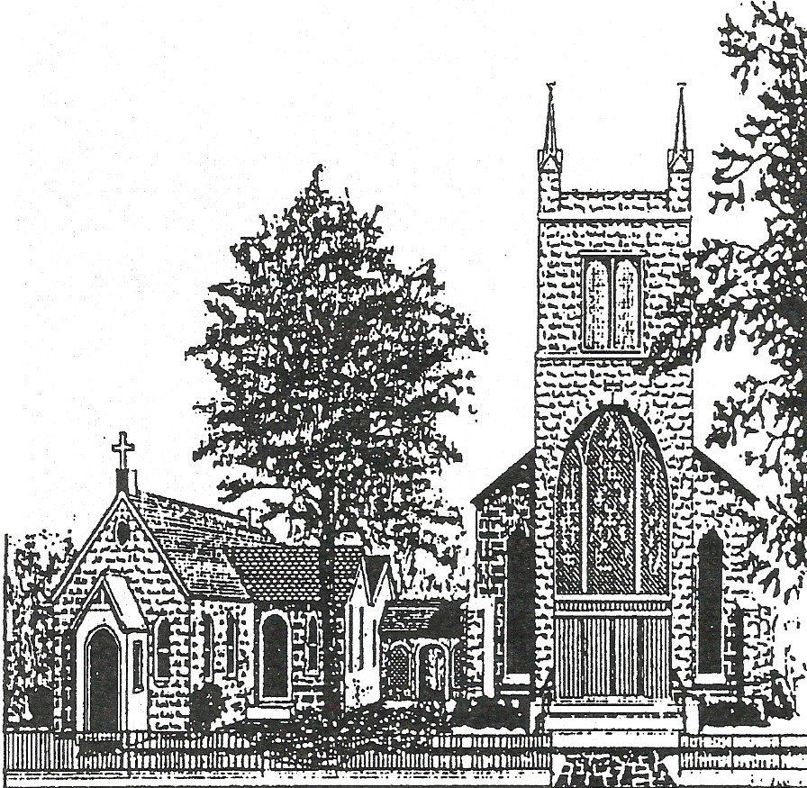

Fifth Sunday of Easter
May 7, 2023
Holy Eucharist-Rite II
10:30 a.m.
Please make sure all phones and other electronic devices are turned off prior to the service.

Hymns and service music can be found in the following resources:

S - in the front of the Hymnal
H - in the Hymnal
W - in Wonder, Love, & Praise (on the end of each row)
L - in Lift Every Voice (on the end of each row)

THE WORD OF GOD

Organ Preludes Fanfare & Trumpet tune on “Westminster Abbey” David Lasky

Processional Hymn Christ Is Made the Sure Foundation H-518 WESTMINSTER ABBEY
Opening Salutation BCP-355
The Collect for Purity BCP-355
Gloria in Excelsis Setting by William Mathias S-278
The Collect of the Day
Almighty God, whom truly to know is everlasting life: Grant us so perfectly to know your Son Jesus Christ to be the way, the truth, and the life, that we may steadfastly follow his steps in the way that leads to eternal life; through Jesus Christ your Son our Lord, who lives and reigns with you, in the unity of the Holy Spirit, one God, for ever and ever. Amen.

Collect for ECS
Compassionate God, you called us to establish Episcopal Community Services of the Diocese of New Jersey: endow us with the vision to balance charitable giving with advocating justice, so that both the source and symptoms of oppression will be overcome; through Jesus Christ our Lord, who lives and reigns with you and the Holy Spirit, one God, now and for ever. Amen.

First Lesson Acts 7:55-60

Lector: A reading from the Acts of the Apostle
Filled with the Holy Spirit, Stephen gazed into heaven and saw the glory of God and Jesus standing at the right hand of God. “Look,” he said, “I see the heavens opened and the Son of Man standing at the right hand of God!” But they covered their ears, and with a loud shout all rushed together against him. Then they dragged him out of the city and began to stone him; and the witnesses laid their coats at the feet of a young man named Saul. While they were stoning Stephen, he prayed, “Lord Jesus, receive my spirit.” Then he knelt down and cried out in a loud voice, “Lord, do not hold this sin against them.” When he had said this, he died.
Lector: The Word of the Lord People: Thanks be to God

Psalm 31:1-5, 15-16 In te, Domine, speravi BCP-622 Anglican Chant setting sung by choir Henry Purcell
1 In you, O Lord, have I taken refuge;
let me never be put to shame; *
deliver me in your righteousness.
2 Incline your ear to me; *
make haste to deliver me.
3 Be my strong rock, a castle to keep me safe,
for you are my crag and my stronghold; *
for the sake of your Name, lead me and guide me.
4 Take me out of the net that they have secretly set for me, *
for you are my tower of strength.
5 Into your hands I commend my spirit, *
for you have redeemed me,
O Lord, O God of truth.
15 My times are in your hand; *
rescue me from the hand of my enemies,
and from those who persecute me.
16 Make your face to shine upon your servant, *
and in your loving-kindness save me.

The Second Lesson 1 Peter 2:2-10
Lector: A reading from the first letter of Peter
Like newborn infants, long for the pure, spiritual milk, so that by it you may grow into salvation— if indeed you have tasted that the Lord is good.
Come to him, a living stone, though rejected by mortals yet chosen and precious in God’s sight, and like living stones, let yourselves be built into a spiritual house, to be a holy priesthood, to offer spiritual sacrifices acceptable to God through Jesus Christ. For it stands in scripture:
“See, I am laying in Zion a stone,
a cornerstone chosen and precious;
and whoever believes in him will not be put to shame.”
To you then who believe, he is precious; but for those who do not believe,
“The stone that the builders rejected
has become the very head of the corner”,
and
“A stone that makes them stumble,
and a rock that makes them fall.”
They stumble because they disobey the word, as they were destined to do.
But you are a chosen race, a royal priesthood, a holy nation, God’s own people, in order that you may proclaim the mighty acts of him who called you out of darkness into his marvelous light.
Once you were not a people,
but now you are God’s people;
once you had not received mercy,
but now you have received mercy.
Lector: The Word of the Lord People: Thanks be to God

Gradual Hymn: When Stephen Full of Power and Grace H-243
SALVATION

The Gospel Please stand John 14:1-14

Deacon: The gospel of our Lord Jesus Christ according to John People: Glory to You Lord Christ
Jesus said, “Do not let your hearts be troubled. Believe in God, believe also in me. In my Father’s house there are many dwelling places. If it were not so, would I have told you that I go to prepare a place for you? And if I go and prepare a place for you, I will come again and will take you to myself, so that where I am, there you may be also. And you know the way to the place where I am going.” Thomas said to him, “Lord, we do not know where you are going. How can we know the way?” Jesus said to him, “I am the way, and the truth, and the life. No one comes to the Father except through me. If you know me, you will know my Father also. From now on you do know him and have seen him.”
Philip said to him, “Lord, show us the Father, and we will be satisfied.” Jesus said to him, “Have I been with you all this time, Philip, and you still do not know me? Whoever has seen me has seen the Father. How can you say, ‘Show us the Father’? Do you not believe that I am in the Father and the Father is in me? The words that I say to you I do not speak on my own; but the Father who dwells in me does his works. Believe me that I am in the Father and the Father is in me; but if you do not, then believe me because of the works themselves. Very truly, I tell you, the one who believes in me will also do the works that I do and, in fact, will do greater works than these, because I am going to the Father. I will do whatever you ask in my name, so that the Father may be glorified in the Son. If in my name you ask me for anything, I will do it.”

Deacon: The Gospel of the Lord People: Praise to You Lord Christ
Sermon The Rev. Charles Messer
The Nicene Creed BCP-358
Prayers of the People Form III BCP-387
The Peace BCP-360
Announcements
THE HOLY COMMUNION

Offertory How Lovely Is Thy Dwelling Place (German Requiem) Johannes Brahms
How lovely is Thy dwellingplace, O Lord of Hosts!
Fr my soul, it longeth, yea, fainteth for the courts of the Lord;
My soul and body crieth out for the living God.
Blest are they that dwell within Thy house;
They praise Thy name evermore.

Presentation (Tune: Lasst Uns Erfreuen)

Praise God from whom all blessings flow.
Praise God, all creatures here below,
Alleluia! Alleluia!
Praise God above, ye heavenly host:
Praise Father, Son, and Holy Ghost.
Alleluia! Alleluia! Alleluia! Alleluia! Alleluia!
Eucharistic Prayer B BCP-367
Sanctus (sung) Setting by Richard Proulx S-125

Acclamation Setting by McNeil Robinson II S-138

Amen Setting by McNeil Robinson II S-146

The Lord’s Prayer BCP-364

Fraction Anthems
Christ Our Passover Setting by David Hurd S-154
Be Known to us, Lord Jesus Gary James WLP-875

The Breaking of the Bread BCP-364
All are Welcome to Receive Communion.

Communion Motet O Taste and See Ralph Vaughan Williams
O taste and see how gracious the Lord is;
Blest is the man that trusteth in Him.

Prayer for Receiving Spiritual Communion
My Jesus, I believe that you are truly present in the Blessed Sacrament of the Altar. I love you above all things, and long for you in my soul. Since I cannot now receive you sacramentally, come at least spiritually into my heart. As though you have already come, I embrace you and unite myself entirely to you; never permit me to be separated from you. Amen.

Post Communion Prayer
Eternal God, heavenly Father, you have graciously accepted us as living members of your Son our Savior Jesus Christ, and you have fed us with spiritual food in the Sacrament of his Body and Blood. Send us now into the world in peace, and grant us strength and courage to love and serve you with gladness and singleness of heart; through Christ our Lord. Amen.

The Blessing BCP-366
Retiring Procession The Church’s One Foundation H-525
AURELIA
The Dismissal BCP-366

Organ Postlude Reflection on “Aurelia” Kevin Norris

The flowers on the altar today are given in celebration of the 11th anniversary of Deacon Sally’s ordination as a Deacon, and Father Chuck’s 5th anniversary as our Rector.

Parish Prayer List
Helen Frances Suzanne Judy Bill Amy George Janice Jim Evan Sally Carol George Brenda
Rich Joel Jim Gail Karen Eric Francine Joseph Peggy Joseph Julie Pat Michele Anna Elaine The Kamera Family Andrew & Judy Emma Bill John Mary Ellen Mother Antoinette
Robbie & Stan Deacon Naomi Liz Joan

Our military:
Christine, Marlene, Joseph, Peter, Bud, Michael, Chris, David, and Tyler
Announcements
MUSIC IN TODAY’S LITURGY: Through the great 50 days of Easter (Easter Day through Pentecost—May28) we will use more festive service settings than in Ordinary Time. All are encouraged to participate as worshippers through song, as we are invited to do by the Psalmists in Holy Scripture. All of the music here at St. John’s—hymns, responses, anthems, instrumental offerings (Prayers do not need words)—is selected to coordinate and amplify the themes of the lessons and prayers appointed for each Lord’s Day, and are offered as prayer to God and proclamation of the gospel. The choir chants the Psalm today in a setting by Henry Purcell (1659– 1695), an English composer of the early Baroque Period whose msical style was distinctly Englash rather than continental. The Offering Anthem is by Johannes Brahms (1833–1897), a German composer, pianist, and conductor of the mid-Romantic era. This anthem is the fourth and central movement of Brahms’ A German Requiem, which is a setting of various scripture texts—this movement is Psalm 84:1-2, 4—but not the text of the Requiem Mass propers. The Communion Motet is a brief setting of Psalm 34:8 by Ralph Vaughan Williams (1872–1958), an important and influential English composer. This Motet was originally composed for the coronation of Queen Elizabeth II in 1953. The Organ Prelude is based on today’s Processional Hymn tune. It is by David Lasky (b. 1957), and American composer and organist. Since 1981, he has been organist and director of music at St. Cecilia’s Church in Leominster, Massachusetts. The Organ Postlude is a reflection on today’s final hymn tune. The setting was composed by Kevin Norris (1939-1991), an American composer and organist.

ST. JOHN’S CHOIR has openings for—and is eager to add—additional volunteer singers in all voice parts. Rehearsals are Sunday mornings at 9:00 AM. There are no musical auditions, but a get-acquainted meeting with Minister of Music, Bill Clisham, in necessary for placement and orientation. If you are interested or know of someone who may be interested, please see Bill Clisham after the Postlude any Sunday morning, or at Coffee Hour following the 10:30 Eucharist.

We appreciate the Participants in Today’s Service:

Presiding The Rev. Charles Messer
Assisting The Rev. Sally Maurer, Deacon
Celebrants The People of St. John’s
Minister of Music Bill Clisham
The Choir of St. John’s
Lector
Acolytes

Altar Flowers-Many Sundays are currently open if you would like to present Altar Flowers in memory of someone or in thanksgiving for something, please fill out this form, or call or email the office to let us know. Cost is $50 for the 2 arrangements at the altar.

Altar Flowers
Name___________________________________
Email____________________________________
Date you would like the flowers to be on the altar_____________
Wording for the bulletin ____________________________________________________________________________________________________________________________________________________________________________________________________________________

Please put this in the offering plate with payment. Make sure the check or cash indicates “Altar Flowers (date)”. Thank you.

This Week’s Parish Calendar

Sun. 5/7 8:00 am Holy Eucharist; Rite I 9:00 am Choir Rehearsal 9:15 am Adult Ed 10:30 am Holy Eucharist Rite II Fellowship Hour Birthday Sunday Vestry Meeting
Tue. 5/9 8:00 am Yoga 7:00 pm N.A.
Wed. 5/10 Noon Holy Eucharist 8:00 pm AA
Thu. 5/11 8:00 Yoga 6:30 pm Bible Study with Potluck Dinner
Sat. 5/13 8:00-9:00 am Yoga
Sun. 5/14 8:00 am Holy Eucharist; Rite I 9:00 am Choir Rehearsal 9:15 am Adult Ed 10:30 am Holy Eucharist Rite II Fellowship Hour

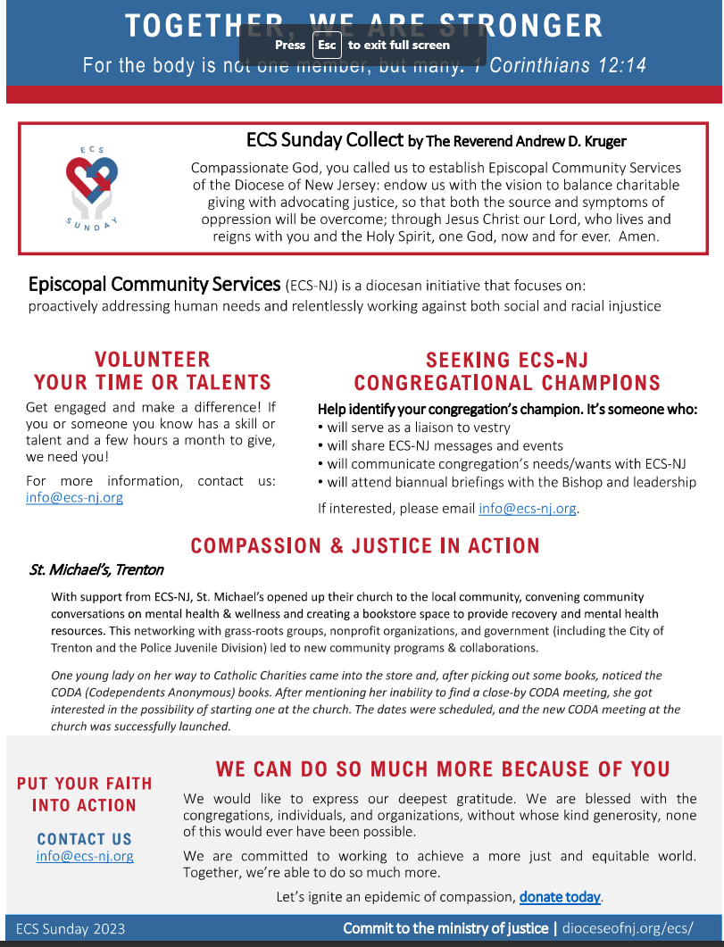

ST. JOHN’S
CHURCH DIRECTORY

Ordained Ministry
The Rev. Charles Messer, Rector Office (856) 935-1798
Cell (610) 800-8795
The Rev. Deacon Sally Maurer, Deacon Cell (856) 297-2385

Lay Leaders
Senior Warden Bill Pankonian (856) 935-7768
Junior Warden Ron Magill (856) 935-5398
Treasurer

The Vestry
Class of 2024 Class of 2025 Class of 2026 Ron Magill Judy Almond Annemarie Lawless
Ann Neff Bill Pankonian Joseph Longo

Parish Staff
Parish Secretary Eileen Miller (856) 935-1798
Parish Sexton Warren Bye (856) 935-1798
Minister of Music William Clisham (908) 472-7597
Livestream Director Brandon Burke

Church Office (856) 935-1798 e-mail: stjohnssalemnj@comcast.net

